* Web Site Goal

**The goal of the site is to be informative and accessible.**

* Describe the goal of your web site in one or two sentences.

**To be a method to teach, inform, get behind a communicate and access merchandise for volleyball**

* What results do I want to see?

**I want to see 7 working pages and a website that I could use in the future**

* List the working title of each page on your web.

**Home page**

**About**

**Community**

**Register**

**Lessons**

**Shop**

**Pricing**

* What information do I need?

**I need pricing for gear so I chose sport sites such as Dick’s sporting good, or Academy Sport for gear and pricing information. I can use the “Meetup App” for information with the communities here in Georgia, as it is a tool to help people gather and play. Using Youtuber “Elevate Yourself” as a credible source for videos. As for the rest I can use a site such as D-Bat to get a general feel for what I want for a site.**

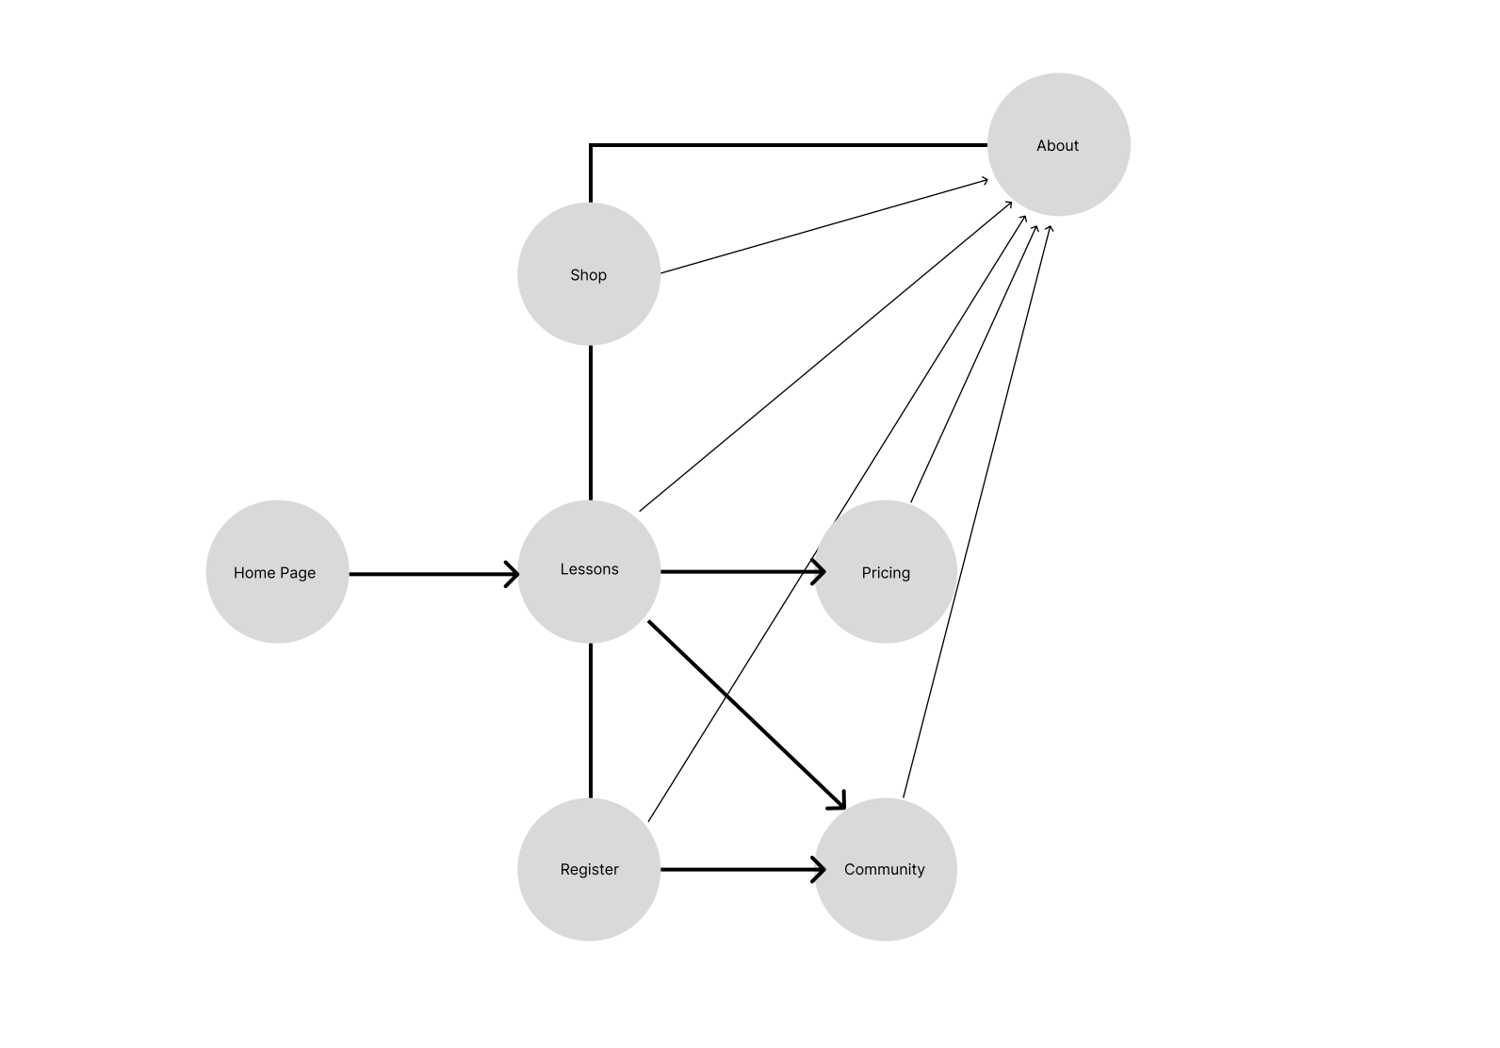**FlowChart**

<https://rovidchavez.github.io/IT3203/>